**PROJECT DESIGN PHASE**

4.1 Problem – Solution Fit

|  |  |
| --- | --- |
| Date | 5th, April 2025 |
| Team ID |  |
| Project Name | Convoconnect |
| Maximum Marks | 2 Marks |

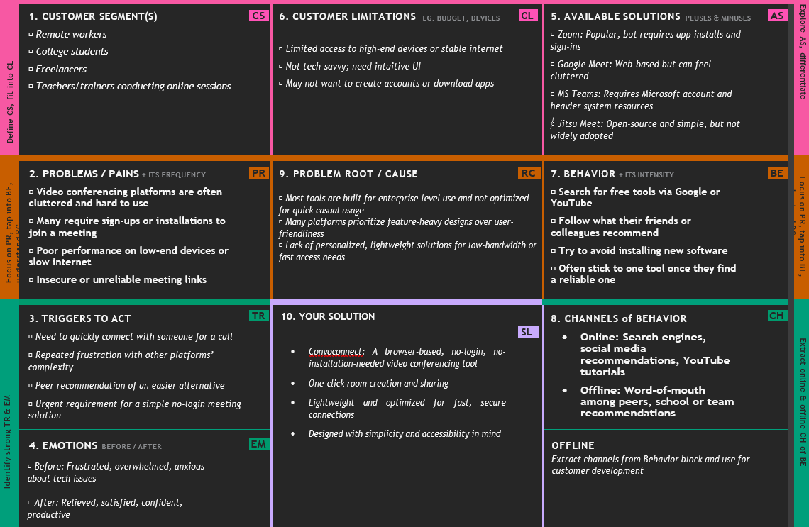

4.2 Proposed Solution

|  |  |
| --- | --- |
| Date | 5th, April 2025 |
| Team ID |  |
| Project Name | Convoconnect |
| Maximum Marks | 2 Marks |

|  |  |  |
| --- | --- | --- |
| S.No. | Parameter | Description |
| 1 | Problem Statement (Problem to be solved) | Many users, especially non-tech-savvy individuals, struggle with accessing and managing video conferencing tools due to complex interfaces, account issues, or compatibility limitations. Current platforms often require multiple steps and technical knowledge, which hinders seamless virtual communication. |
| 2 | I  idea / Solution description | ConvoConnect is a web-based video conferencing platform that simplifies the entire virtual meeting experience. It offers one-click meeting creation and joining, minimal setup, no mandatory sign-ups, and a clean, user-friendly interface. The platform supports secure, real-time video and audio communication, screen sharing, and chat functionality. |
| 3 | Novelty / Uniqueness | The platform differentiates itself with instant access to meetings without complex installation, registration, or setup. It focuses on intuitive UI/UX for all age groups, especially targeting users unfamiliar with modern tech. Integration with calendar invites and link-based joining make it lightweight and easy to use. |
| 4 | Social Impact / Customer Satisfaction | ConvoConnect reduces digital barriers for senior citizens, educators, and small businesses by promoting easy and inclusive communication. It enhances digital inclusion and ensures everyone can connect without technical difficulties. The simplicity and accessibility result in higher user satisfaction and retention. |
| 5 | Business Model (Revenue Model) | Freemium model: Free access for basic features and individual meetings. Revenue generated from premium subscriptions offering advanced features like session recording, analytics, branding options for businesses, and higher participant limits. Additionally, targeted ad placements in the free version. |
| 6 | Scalability of the Solution | The platform is built using scalable technologies like ReactJS, Node.js, and WebRTC. It can handle increasing user traffic with scalable cloud infrastructure. Potential future integrations include enterprise tools, mobile apps, and AI-driven meeting enhancements (e.g., transcriptions, summaries). |

4.3 Solution Architecture

|  |  |
| --- | --- |
| Date | 5th, April 2025 |
| Team ID |  |
| Project Name | Convoconnect |
| Maximum Marks | 4 Marks |

